Computer Networks Lab 4

Name: CAO Xinyang

HDU ID: 20321308

**1. Adding equipment.**

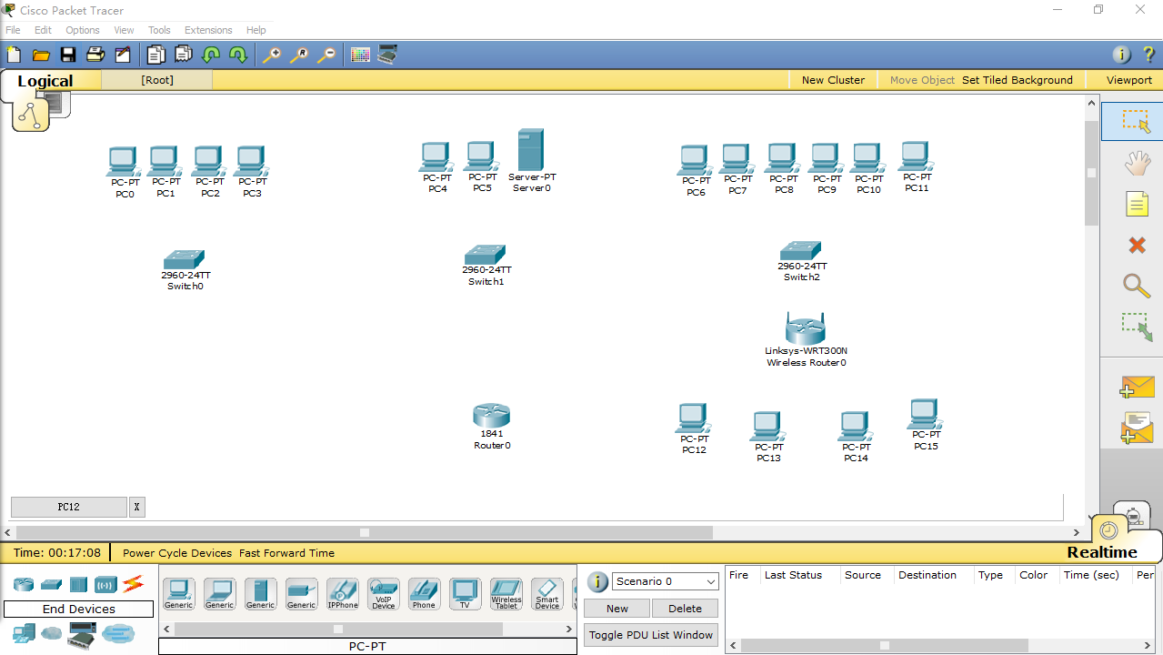

**2. Installing the Wi-Fi module in the PC.**

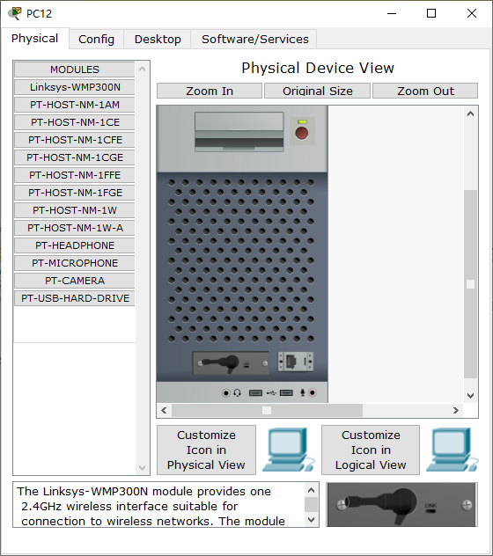 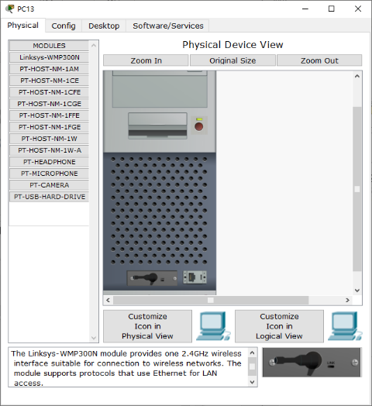

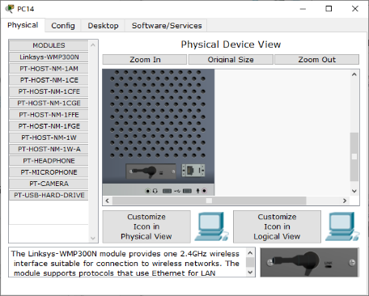 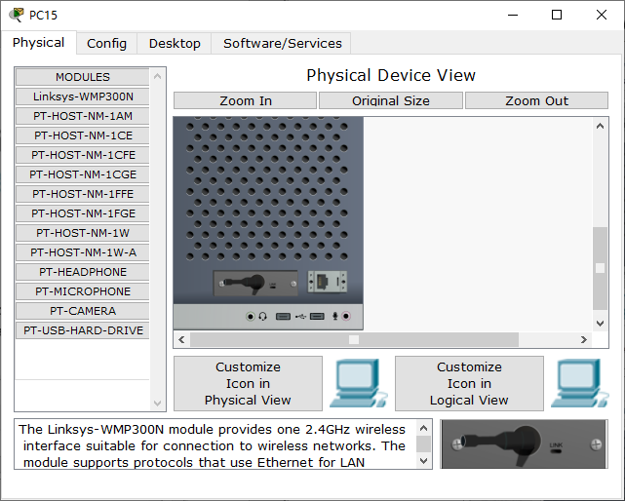

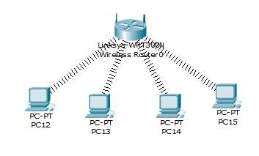

**3.** **Setting up the PCs of the first and second departments.**

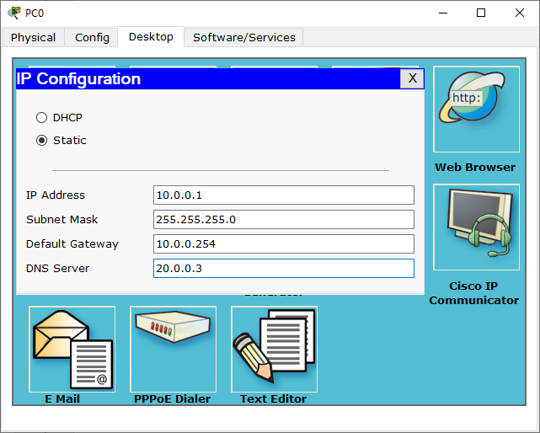 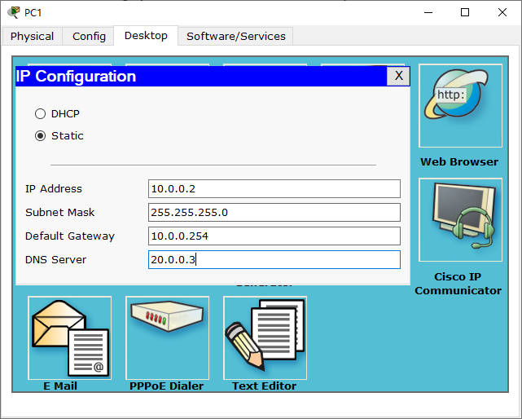

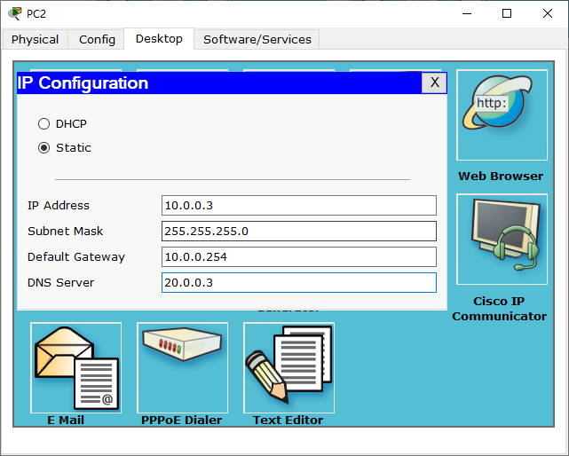 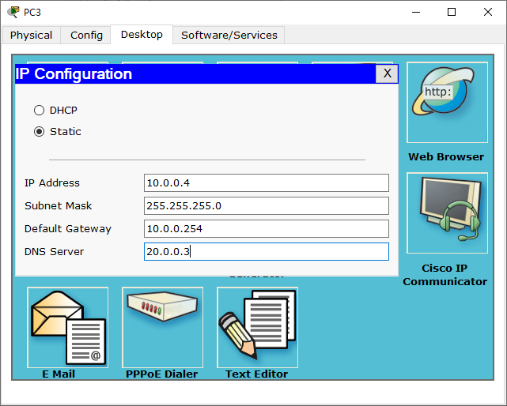

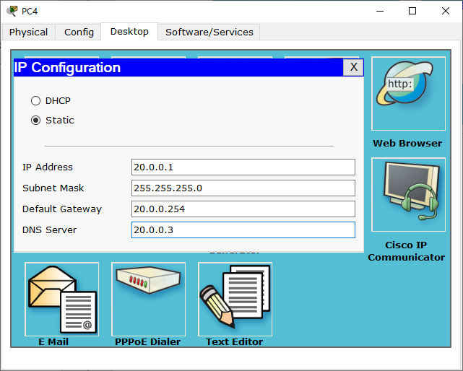 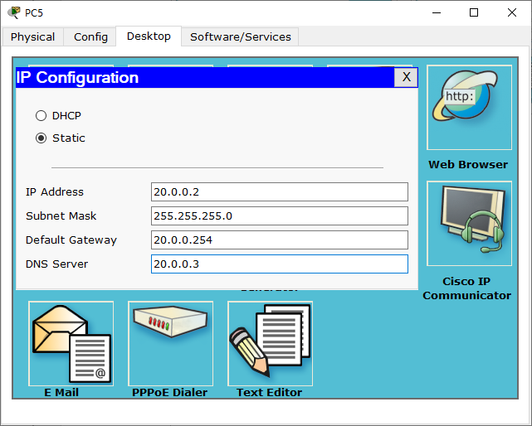

set the following settings on the server:

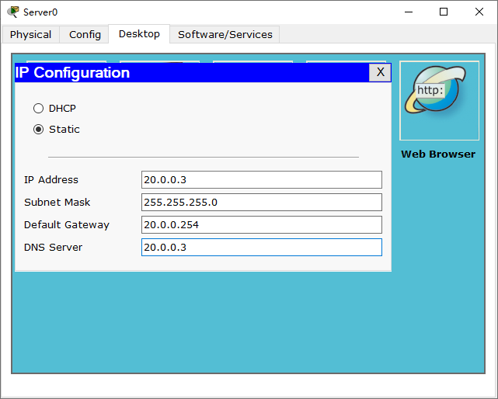

**4. Setting up the third department.**

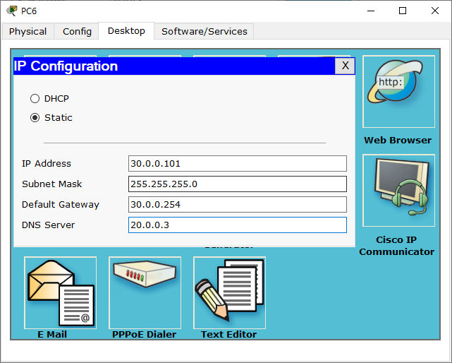 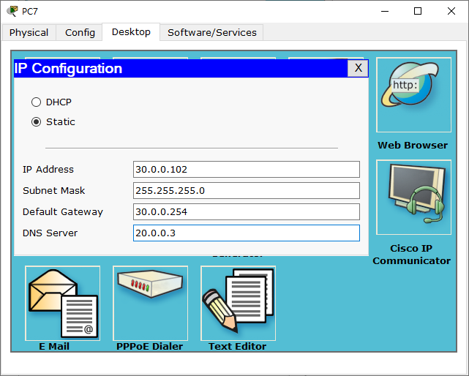

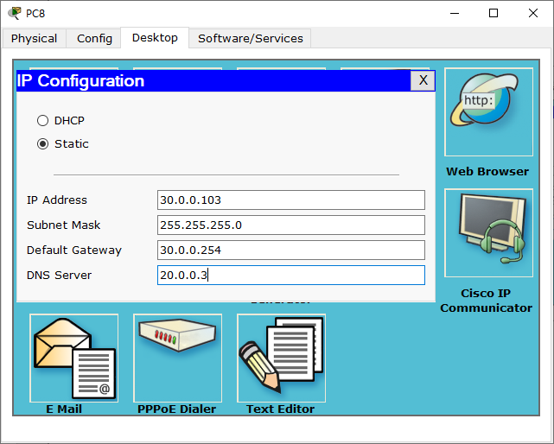 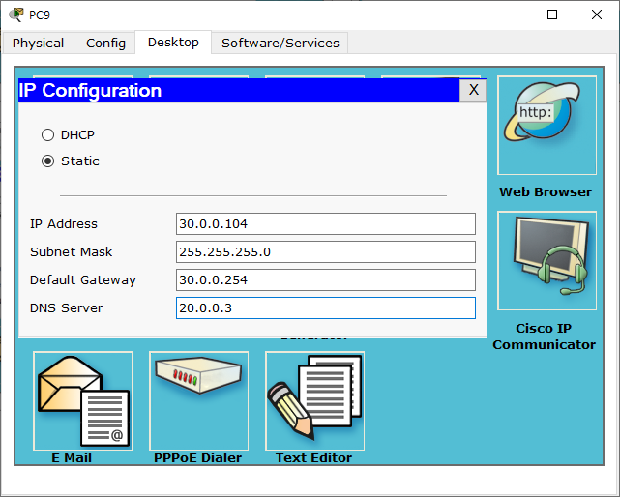

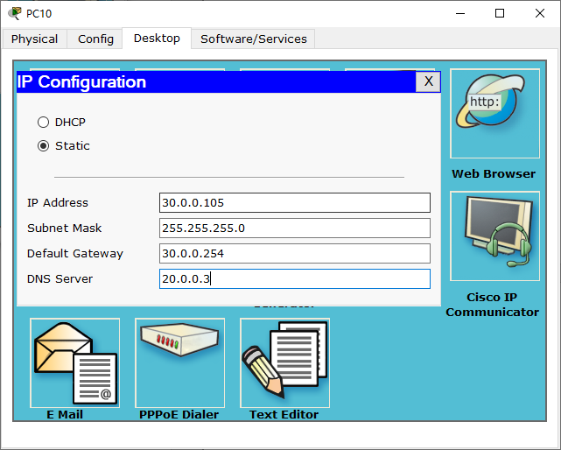 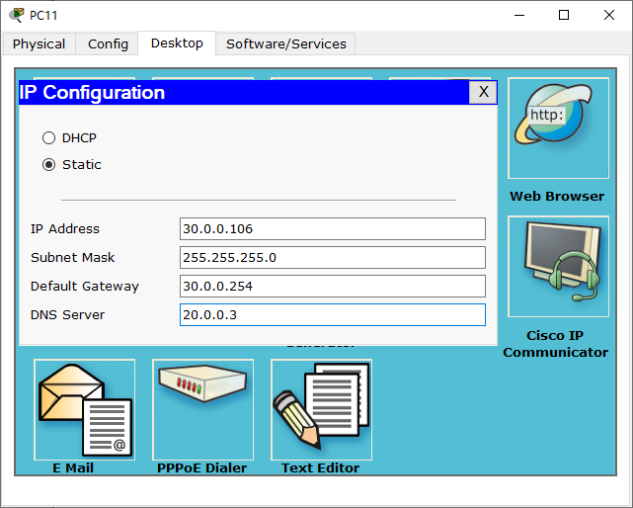

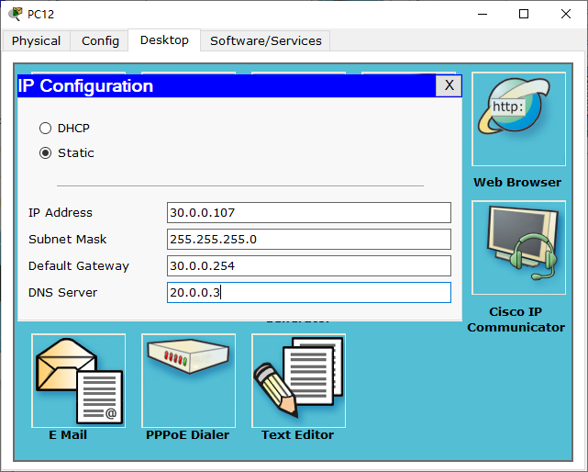 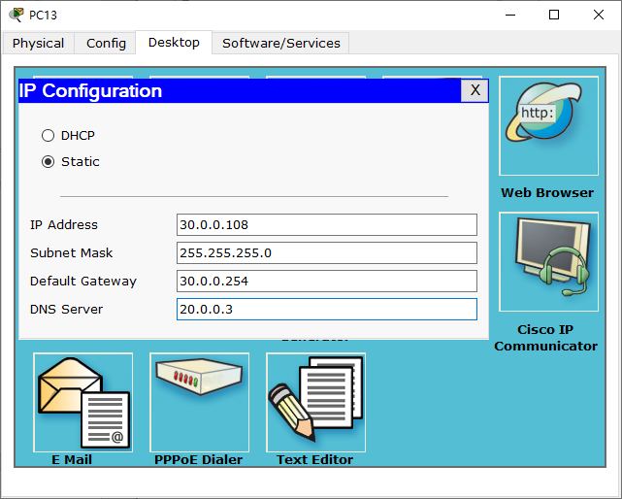

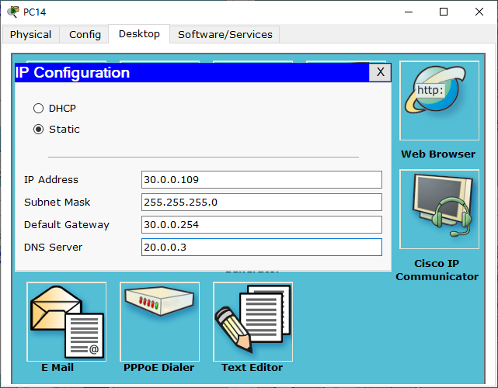 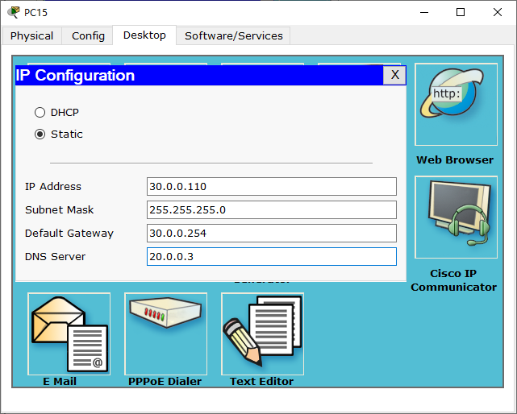

**5. Configuring the router.**

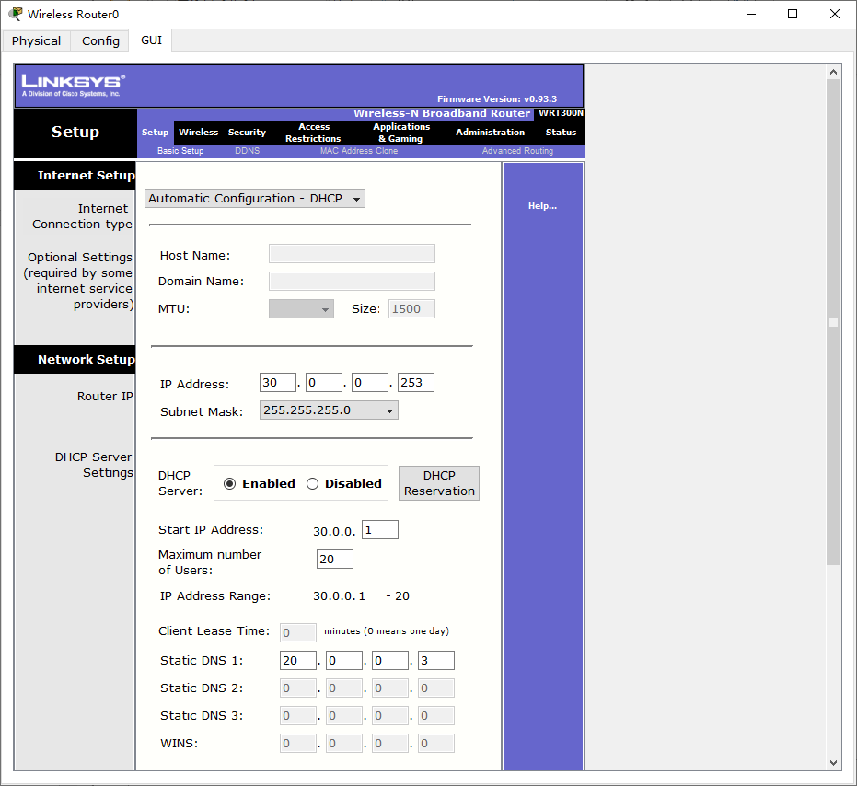

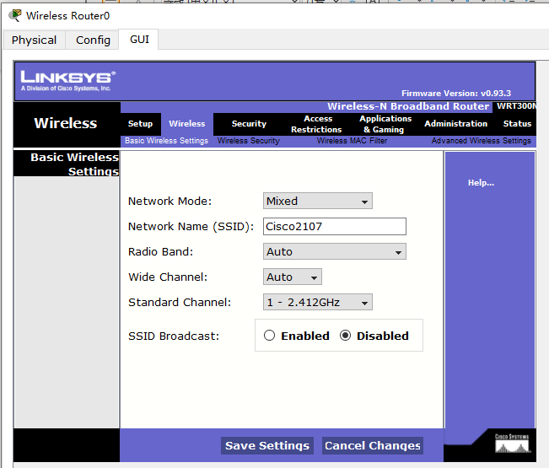

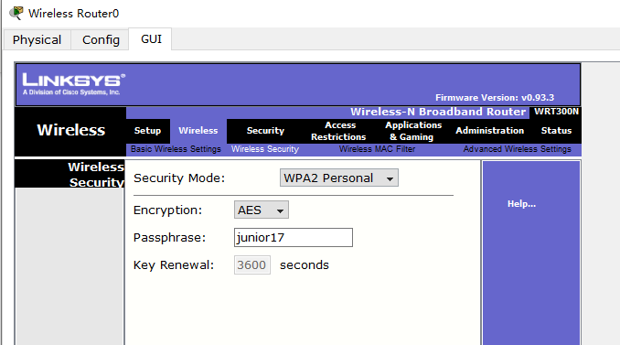

Setting up wireless PCs.

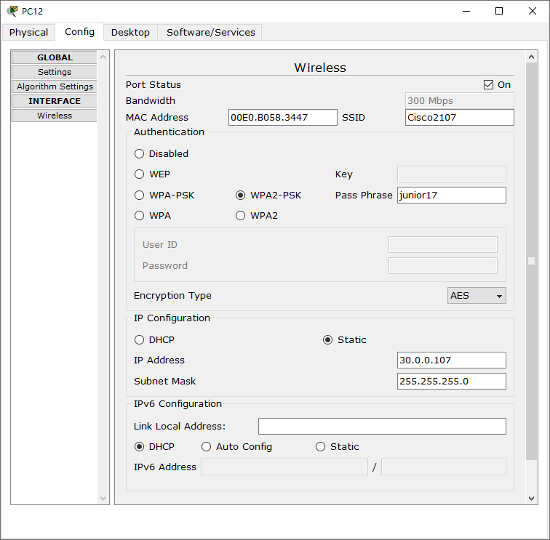 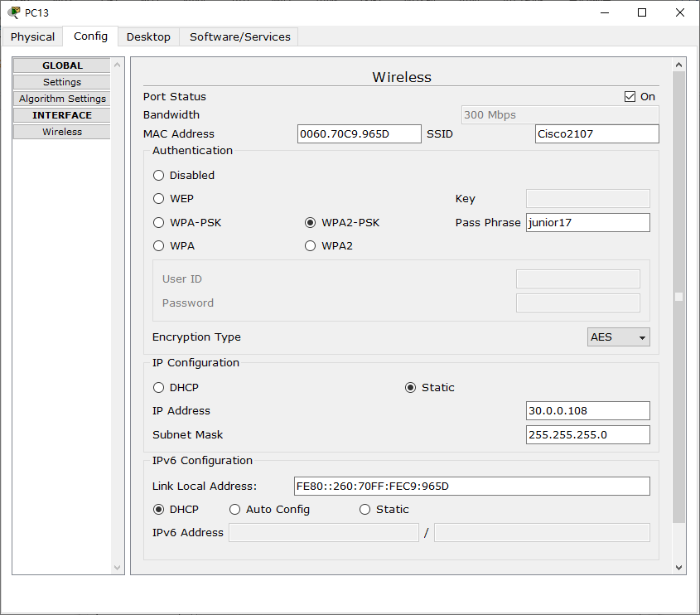

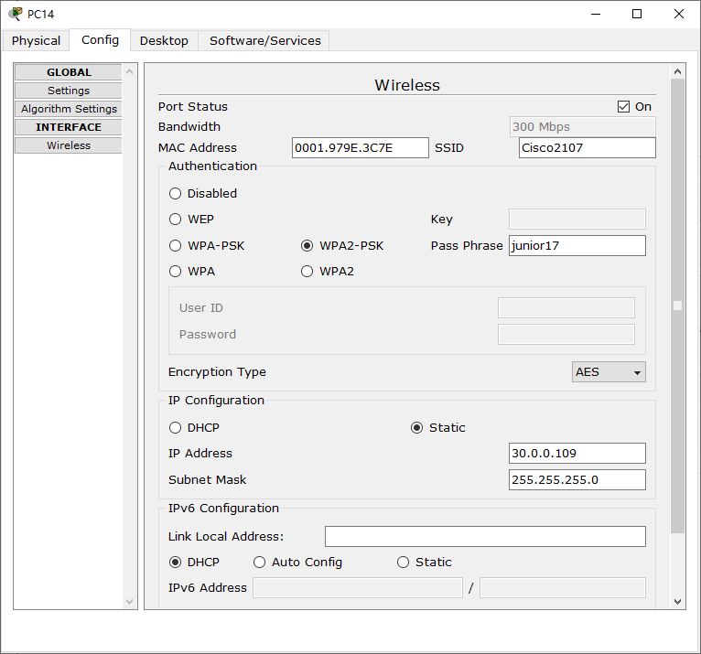 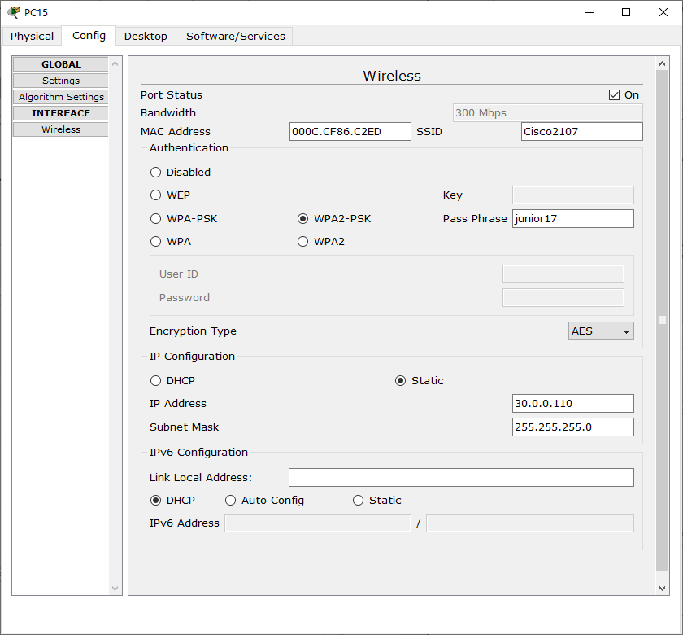

**6. Connect the cables and connect the departments.**

Connect the PC with a twisted pair.

In all switches, connect the cables to FastEthernet clockwise. In the router, connect to the gigabit connector, having previously turned it on.

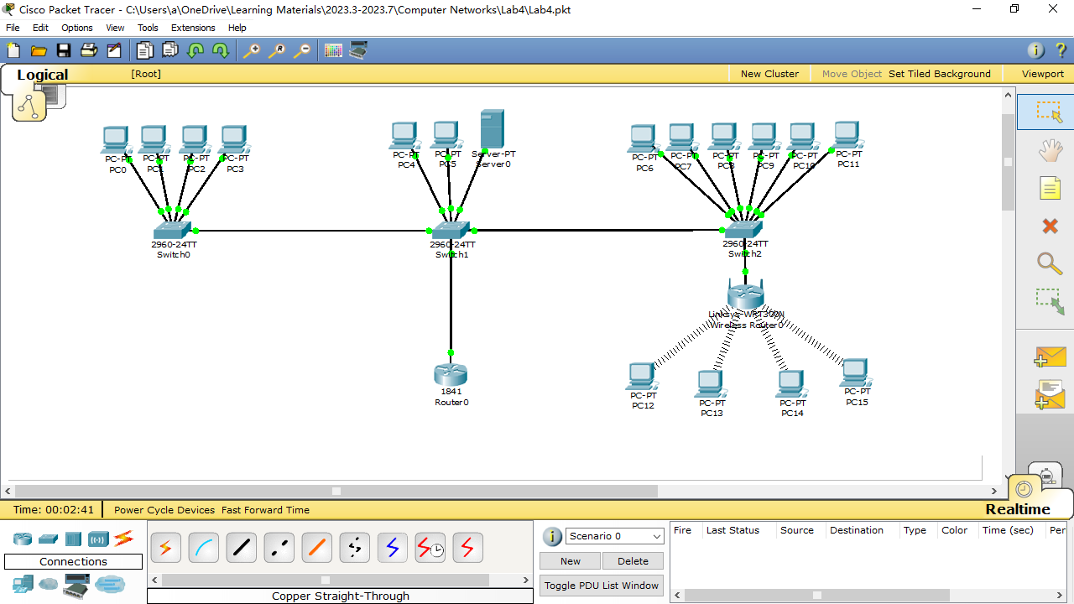

configure VLANs on all switches

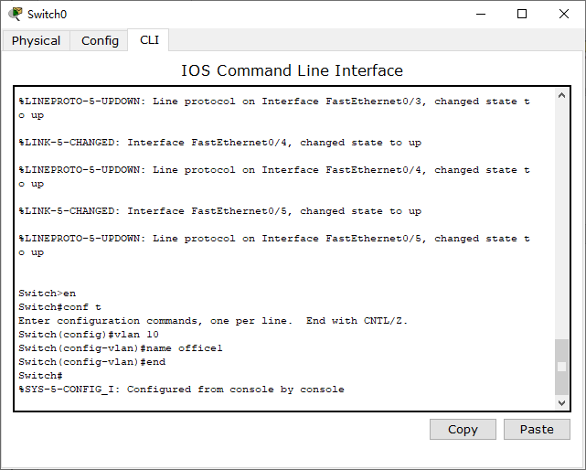

Open the switchboard in the second department and write the following commands:

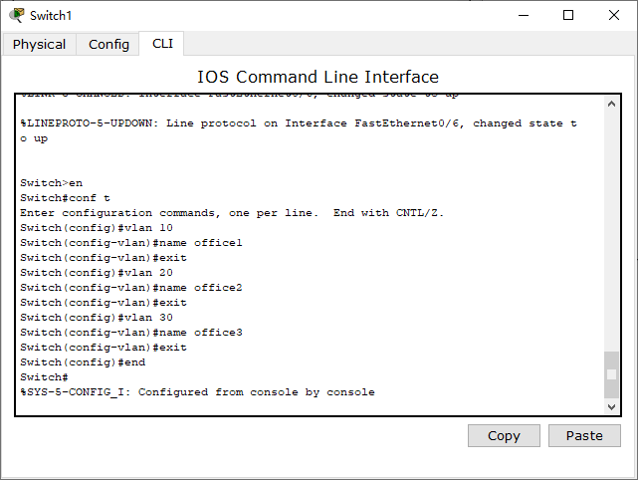

Open the switchboard in the third department and write the following commands:

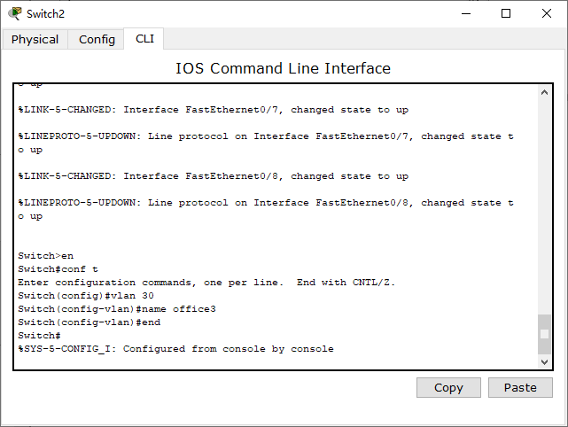

set VLAN 10 on the first switch for all ports to which there is a connection

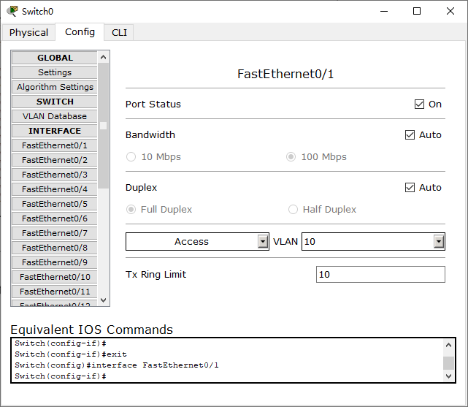 ...(Fa0/2-Fa0/5 is the same as Fa0/1)

On the second switch, you need to set the port to which the switch from the first department of VLAN – 10 is connected, from the third VLAN – 30, and 2 PCs and the server of the second department of VLAN – 20. That is, Fa0/1 – VLAN 10, Fa0/2- Fa0/4 – VLAN 20, Fa0/5 – VLAN 30. Fa0/6, connecting the switch and the router are set to Trunk mode.

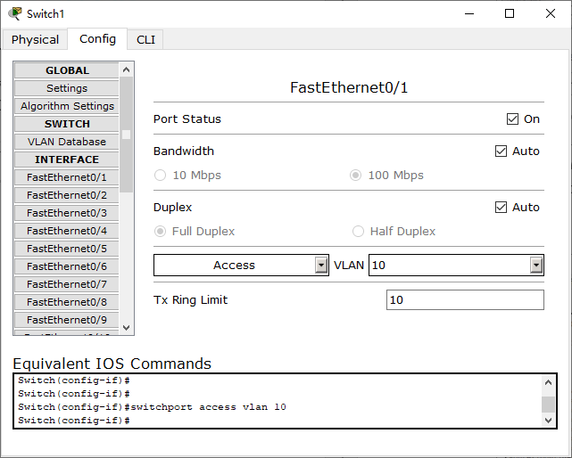 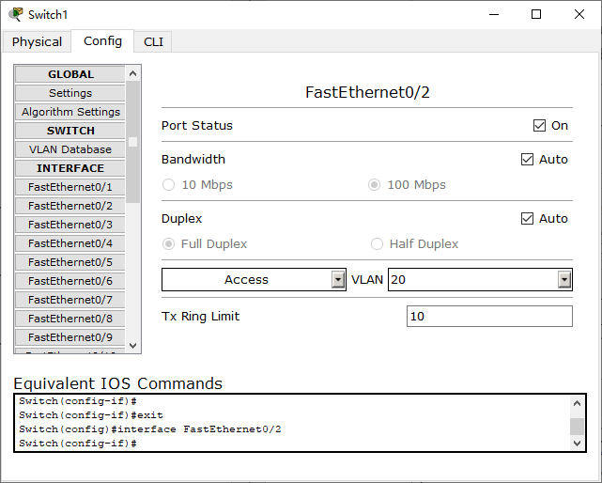 …(Fa0/3- Fa0/4 are as same as Fa0/2)

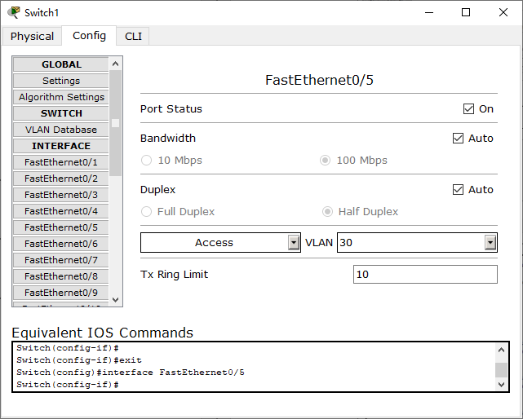 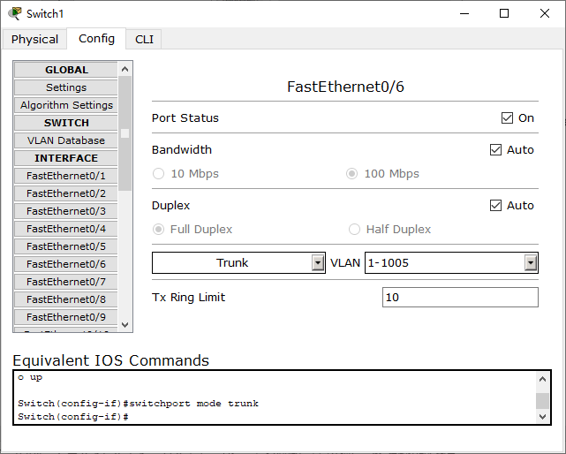

On the third switch, set VLAN 30 (Fa0/1-Fa0/8) to all ports.

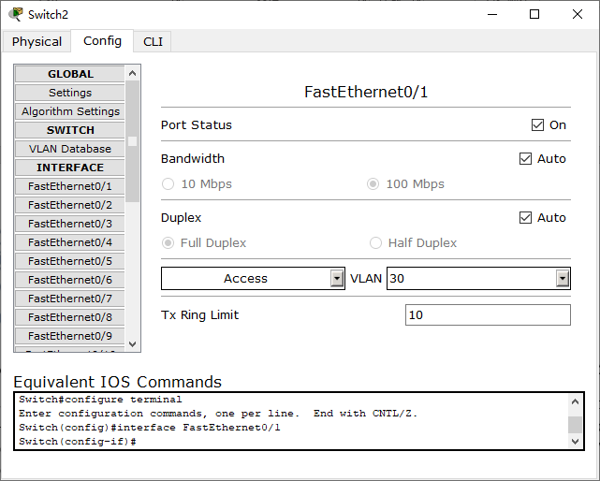 …(Fa0/2-Fa0/8 are as same as Fa0/1)

configure the router to work with the VLAN, go to the CLI tab and prescribes commands there:

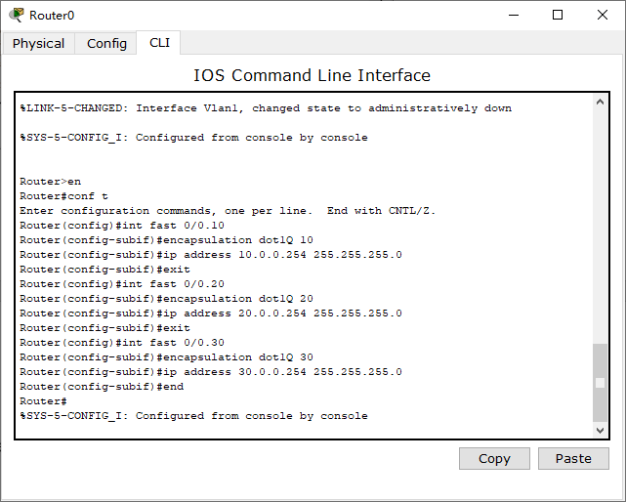

test the network with the ping command.

The first department:

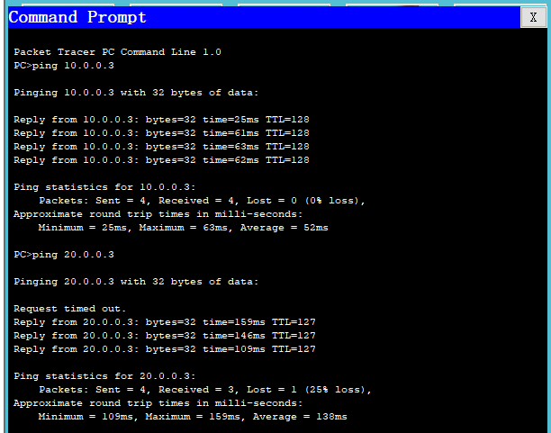

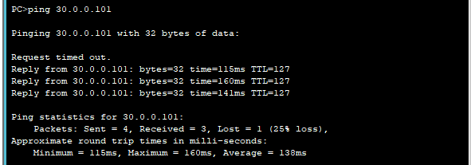

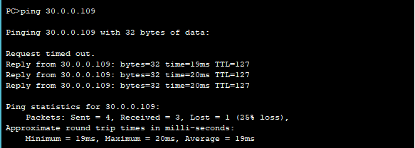

Second department:

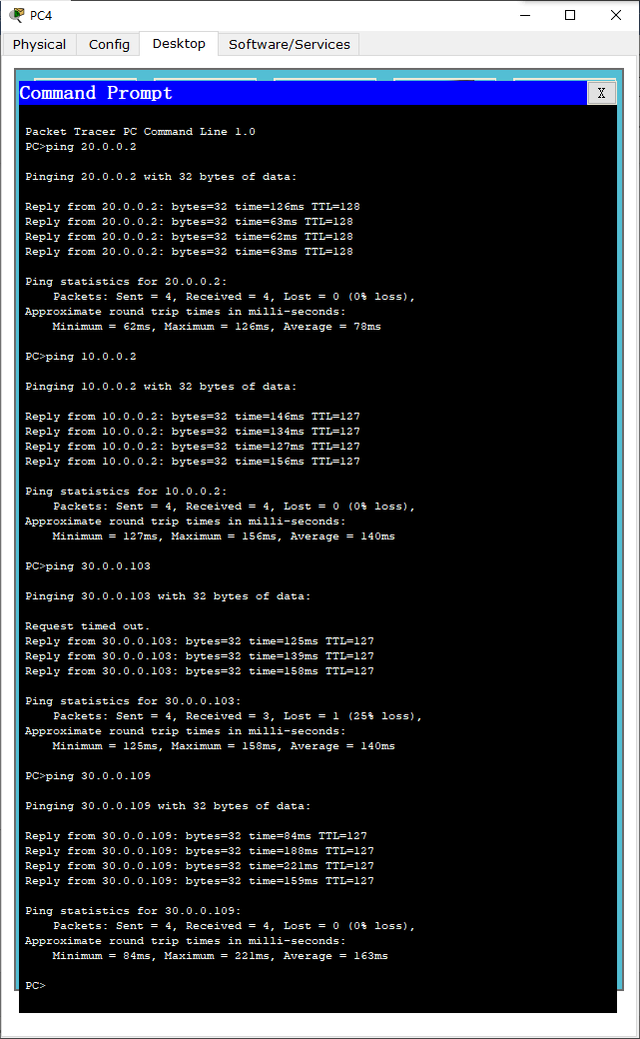

Third department (cable):

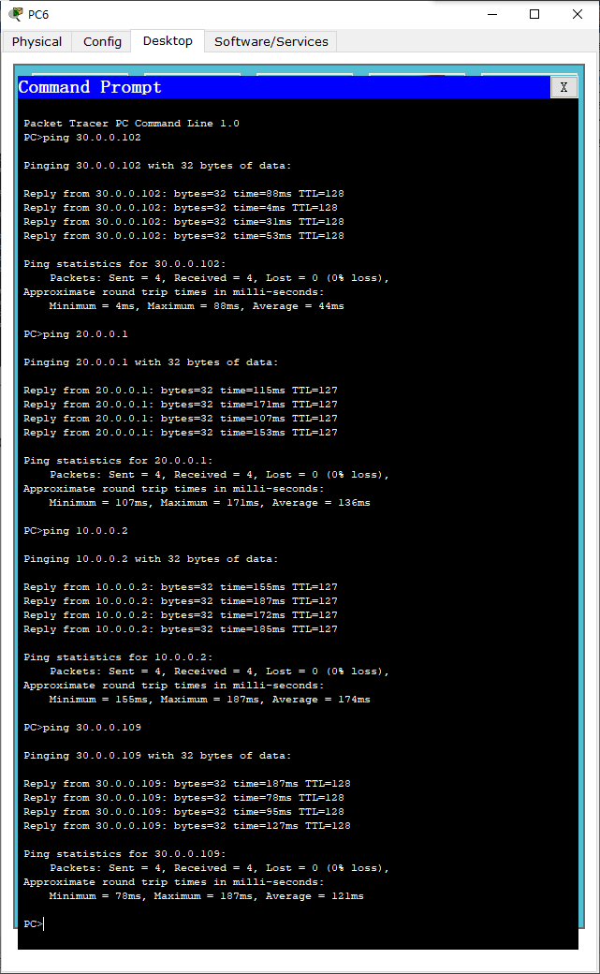

Third Department (Wi-Fi):

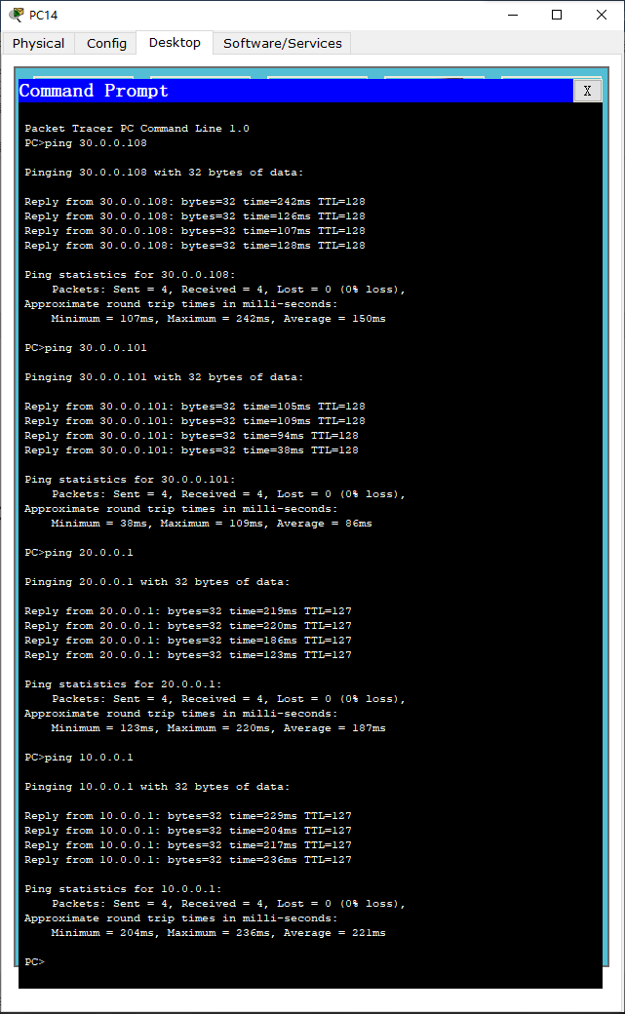

7. Server setup.

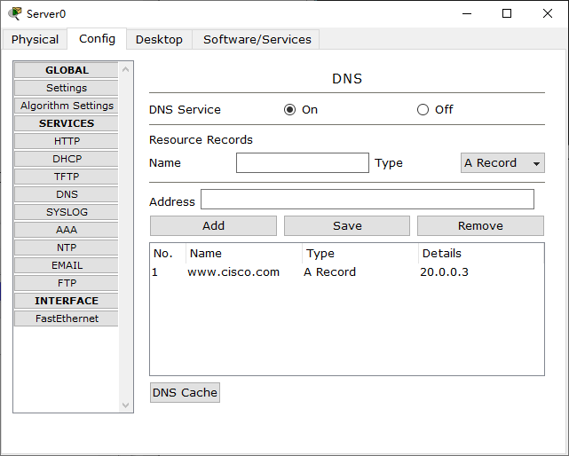

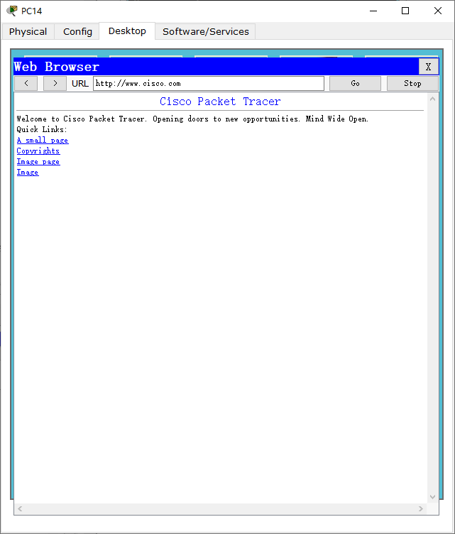

**8. (Done) Configure SSH.**

go into the router and write commands:

Router>en

Router#clock set 10:10:00 13 Oct 2017

Router#conf t

Router(config)#ip domain name ssh.dom

Router(config)#crypto key generate rsa

Router(config)#service password-encryption

Router(config)#username Valery privilege 15 password 8 junior17

Router(config)#aaa new-model

Router(config)#line vty 0 4

Router(config-line)#transport input ssh

Router(config-line)#logging synchronous

Router(config-line)#exec-timeout 60 0

Router(config-line)#exit

Router(config)#exit

Router#copy running-config startup-config

**9. (Done) Configure the protection against on each switch.**

open the switch and write commands:

Switch>en

Switch#conf t

Switch(config)#interface range fastEthernet 0/X-Y

Switch(config-if-range)#switchport mode access

Switch(config-if-range)#switchport port-security

Switch(config-if-range)#switchport port-security maximum K

Switch(config-if-range)#switchport port-security mac-address sticky

Switch(config-if-range)#switchport port-security violation shutdown

Switch(config-if-range)#end

As a result , the work was done as follows:

